Year 12
Physical Education Studies
Sports Psychology

 | Performance Routine | Imagery | Relaxation | Self-Talk  (Positive) | Self-Talk  (Negative) | Goal Setting
Arousal | Increase or decrease | Increase or decrease | Decrease | Increase | Decrease | Increase or decrease (if goal is not met)
Stress | Decreases | Increases or Decreases | Decreases | Decreases | Increases | Increase or decrease (if goal is not met)
Motivation | Increase | Increase | Decrease | Increase | Decrease | Increase or decrease (if goal is not met)
Concentration | Increases | Increases | Increases or decreases | Increase | Decrease | Increase or decrease (if goal is not met)
Self-Confidence | Increase | Increase | Increase | Increases | Decreases | Increase or decrease (if goal is not met)

GRIPS and SMACS

Goal Setting:
Specific
Challenging
Controllable
Attainable
Measurable
Personal

Group Cohesion relates to how well a group works together and stays together.
- Based on two things
  - Task cohesion
    - How many teammates are on the same wavelength in terms of what they want to achieve. Eg. A championship vs for fun
  - Social cohesion
    - How well the teammates get along and the degree to which team members enjoy being together
- Task and social cohesion are independent of each other

Measuring cohesiveness
- Sociograms
- Questionnaires
- Observation

Carron’s Model
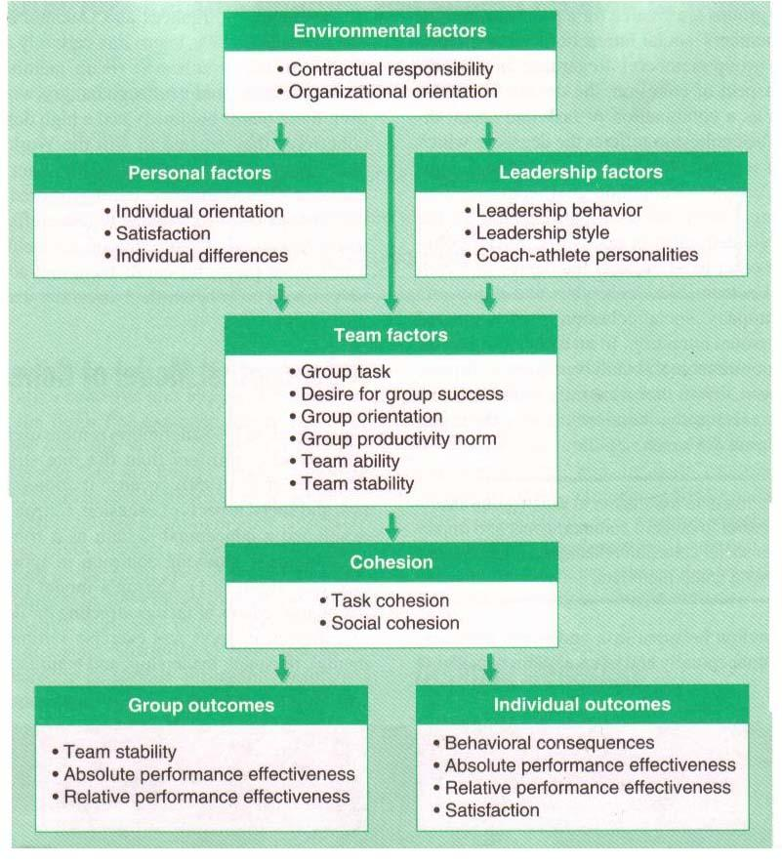
- Environmental factors
  - Contracts
  - Family/Significant other expectations
  - Age
  - Geographical limitations
  - Group size
- Personal factors
  - Task Motivation = leads to task cohesion
  - Affiliation motivation = leads to social cohesion
  - Self-motivation
  - Individual satisfaction
    - Attitudes
    - Goals
    - Level of commitment
    - Expectations
- Leadership factors
  - Most appropriate style of leadership must be used
  - Good leaders will
    - Set team goals
    - Individual roles
    - Team rules
    - Standards of behaviour
  - Leaders must be consistent with their players and have clear communication
  - Compatibility between players and leaders essential in team cohesion
- Team factors
  - Team stability
  - Length of time team has been together
  - Prior success/failure
  - Team goals
  - Type of sport (team or individual)
  - Team norms for productivity
  - 3 levels of communication/interaction
    - Co-acting
- Working together as a team but no communication between members
- Scores are dependent on individual scores
- Eg. Golf, darts
    - Interacting
- Requires a high level of communication
- Eg. ball games such as basketball which require a high level of communication and interaction so that optimum performance is to be achieved
    - Mixed
- Combination between co-acting and interacting activities
- Eg. cricket

Other factors impacting Cohesion
- Common Values
- Group Identity
- Goals
- Roles

Task cohesion is developed by:
- Clear and regular communication
- Clear and understood expectations/norms
- Clear individual roles for each player
- Pride within subunits – defence, midfield, offence
- Challenging by realistic goals for both team and players
- Fair and consistent with the group = equal treatment
- Prioritise team goals over individual goals
- Promote high levels of motivation
- Regular team meetings

Social cohesion is developed by:
- Social interaction away from the sport
- Open and honest communication
- Resolve conflicts quickly
- Team building exercises
- Establish team standards of presentation
- Trust and respect within the group
- Informal roles within the group

Barriers to group cohesion
- Personality clashes
- Unclear/conflicting roles
- Frequent changes to the group
- Disagreement on group objectives
- Power struggle between players

Benefits of Cohesion
- Extensive communication and motivation within the group
- Increased feeling of the group as a whole
- Players work together to achieve team goals ahead of personal goals
- Players enjoy others success
- More successful in achieving their goal
- Members in groups that are cohesive are more satisfied with that group and are willing to stay in the group longer

Social loafing (Ringlemann Effect)
- The tendency of individuals to lessen their effort when they are part of a group – the larger the group, the greater the chance of social loafing

Why does loafing occur?
- Individual athlete sees that other athletes aren’t working hard giving him the impression that he doesn’t have to work hard
- Belief that their efforts wont make a difference to the team and little to any effect on the outcome
- Easier to hide in a pack (avoiding hard work)
- Belief that their efforts are not essential to achieving the goal

Impact of Social Loafing on Individual and Team Performance
- Social loafing causes individual and team performance to be below optimal
- Individual effort increases where each player’s input is identifiable
  - Leads to an increase in individual and team performance

Minimising Social Loafing
- Write a team contract which states
- Develop rules of conduct
- Create appropriate group sizes
- Evaluate all members of a group individually = members individually accounted for

